Thursday, December 7, 2023

Dear Friend,

The Spartanburg County Foundation invites you to help others be inspired by those who inspire you.
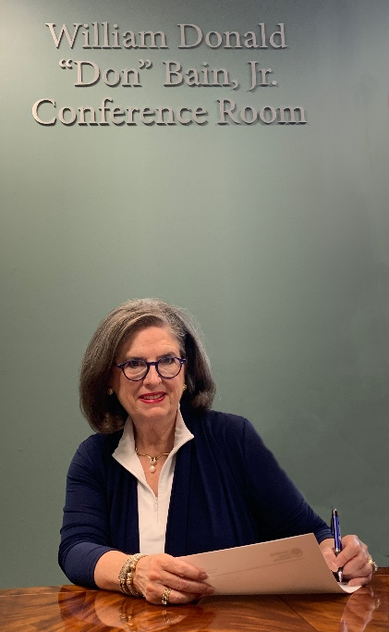
When Trustee Nancy Coté comes to work on Foundation projects, she feels a special sense of connection when that work leads her to the William Donald “Don” Bain, Jr. Conference Room, named after her father. Don Bain served as a Trustee from 1980-1987 and instilled in Nancy a commitment to serving the community. When the Foundation shared naming opportunities, she knew it would be a great tribute to her father and help carry forward his legacy.
“Daddy loved the Foundation. He believed in its work, and so do we. Paul and I loved honoring his legacy this way so that others may be inspired by him when they work in that conference room.”
When you select a naming opportunity to honor someone who has inspired you, their name and legacy have a permanent home at the Spartanburg County Foundation. It’s a home that attracts thousands of visitors each year – each life touched by the commitment made to community philanthropy by you and those who have inspired you.
Please review the specific opportunities listed on the back of this letter and reach out to either Troy Hanna, SCF President and CEO, or Karen Nichols, Director of Philanthropic Services, to review the next steps to secure your desired naming opportunity.
With gratitude,

Troy M. Hanna
SCF President & CEO

We’re YOUR Community Foundation!
Naming opportunities on the Spartanburg County Foundation Campus are available in both our SCF Administrative building and within the Robert Hett Chapman III Center for Philanthropy.
Proceeds from the Center for Philanthropy naming opportunities benefit the Center’s Capital Campaign Fund and include:
- Gallery of Philanthropy $1,000,000
- Convening Partner $100,000
- Gateway Hallways (4) $100,000
- Coffee Corner $50,000
- Mezzanine, second floor $25,000
- Technology Partner $1,000,000
- Atrium Media Partner $100,000
- Interior Furnishings $500,000
Proceeds from the naming opportunities in the SCF Administrative Building benefit the Community Impact Fund #0001 and contribute to funds available for community grantmaking.
- President’s Office $40,000
- President’s Conference Room $40,000
- Finance Office $40,000
- Staff Office (7) $35,000
- Atrium $100,000
- East Hall $50,000
- North Hall $50,000
- Technology Partner, Zimmerli Boardroom $50,000
We welcome you to tour our campus as you consider these naming opportunities. Whether you are considering the opportunity to honor your family legacy, or honor others within our community, we will help you find the right fit. When you select a naming opportunity, appropriate signage will be created, and you will receive a special invitation to see how the signage is placed to forever commemorate the person, family, or business you have honored.
To secure a naming opportunity, please contact Troy Hanna, SCF President & CEO or Karen Nichols, Director of Philanthropic Services, at 864-582-0138 or knichols@spcf.org, or complete the form below and return it in the envelope provided:
Name :______________________________________________________________________________________________

Email: __________________________________________________________

Phone: _________________________________________________________
I would like to discuss an opportunity in the Center for Philanthropy Administrative Building

In honor/memory of ____________________________________________________________

